

**Module Code & Module Title**

**CS6P05NI Final Year Project**

**Assessment Weightage & Type**

**40% Final Project Report**

**Year and Semester**

**2021-22 Autumn**

**Student Name: Abhishek Rokaya**

**London Met ID: 19030695**

**College ID: NP01CP4A190164**

**Internal Supervisor: Mohit Sharma**

**External Supervisor: Ankit Tandukar**

**Assignment Due Date: 27th April 2022**

**Assignment Submission Date: 27th April 2022**

**Word Count:**

*I confirm that I understand my coursework needs to be submitted online via Google Classroom under the relevant module page before the deadline in order for my assignment to be accepted and marked. I am fully aware that late submissions will be treated as non-submission and a marks of zero will be awarded.*

**Abstract**

Table of Contents

1. Introduction 1

1.1 Project Description 1

1.2 Current Scenario 2

1.3 Problem domain and project as a solution 2

1.4 Aim and Objectives 2

1.5 Structure of the report 2

1.5.1 Background 2

1.5.2 Development 2

1.5.3 Testing and Analysis 2

1.5.4 Conclusion 2

2. Background 3

2.1 About the end users 3

2.2 Understanding the solution 3

2.3 Similar Projects 3

2.4 Comparisons 3

3. Development 4

3.1 Considered Methodologies 4

3.2 Selected Methodology 4

3.3 Phases of Methodology 4

3.4 Survey 4

3.4.1 Pre-Survey Results 4

3.4.2 Post-Survey Results 4

3.5 Requirement Analysis 4

3.6 Design 4

3.7 Implementation 4

4. Testing and analysis 5

4.1 Test Plan 5

4.1.1 Unit Testing, Test Plan 5

4.1.2 System Testing, Test Plan 5

4.2 Unit Testing 5

4.3 System Testing 5

4.4 Critical Analysis 5

5. Conclusion 6

5.1 Legal, Social and Ethical Issues 6

5.1.1 Legal Issues 6

5.1.2 Social Issues 6

5.1.3 Ethical Issues 6

5.2 Advantages 6

5.3 Limitations 6

5.4 Future Work 6

6. Reference 7

7. Bibliography 8

8. Appendix 9

8.1 Appendix A: Pre-Survey 9

8.1.1 Pre-Survey Form 9

8.1.2 Sample of filled pre-survey forms 9

8.1.3 Pre-Survey Result 9

8.2 Appendix B: Post-Survey 9

8.2.1 Post-Survey Form 9

8.2.2 Sample of Filled Post-Survey Forms 9

8.2.3 Post-Survey Result 9

8.3 Appendix C: Sample Codes 10

8.3.1 Sample code of the UI 10

8.3.2 Sample code for the Automation Script 10

8.4 Appendix D: Designs 10

8.4.1 Gantt Chart 10

8.4.2 Work Breakdown Structure 10

8.4.3 Algorithms and Flowcharts 10

8.4.4 Hardware Architecture 10

8.4.5 Data Flow Diagram 11

8.4.6 Use Case 11

8.4.7 Wireframes 11

8.5 Appendix E: Screenshots of the System 11

8.6 Appendix F: User Feedback 11

8.6.1 User Feedback Form 11

8.6.2 Sample of Filed User Feedback Forms 11

8.7 Appendix G: Future Work 11

8.7.1 Readings for future work 11

**List of Figures**

Figure 1: Survey of problem 1

Figure 2: Survey of solution 1 2

Figure 3: Survey of solution 2 3

Figure 4: RUP Methodology 8

Figure 5: Prototype Methodology 9

Figure 6: Incremental Methodology 9

Figure 7: Dent-inn 11

Figure 8: DentaLife 12

Figure 9: Kumari Dental Care 13

Figure 10: Use Case Diagram 16

Figure 11: Wireframe 1 22

Figure 12: Wireframe 2 23

Figure 13: Wireframe 3 24

Figure 14: Wireframe 4 25

Figure 15: Wireframe 5 26

Figure 16: Wireframe 6 27

Figure 17: Wireframe 7 28

Figure 18: Wireframe 8 29

Figure 19: Wireframe 9 30

Figure 20: Wireframe 10 31

Figure 21: Wireframe 11 32

Figure 22: Wireframe 12 33

Figure 23: Wireframe 13 34

Figure 24: Wireframe 14 35

Figure 25: Wireframe 15 36

Figure 26: Landing Page - HTML 1 37

Figure 27: Landing Page HTML 2 37

Figure 28: Landing Page CSS 38

Figure 29: ER Diagram 39

Figure 30: Survey Question 1 43

Figure 31: Survey Question 2 44

Figure 32: Survey Question 3 44

Figure 33: Survey Question 4 44

Figure 34: Survey Question 5 45

Figure 35: Survey Question 6 45

Figure 36: Survey Question 7 46

Figure 37: Survey Question 8 46

Figure 38: User Appointment Relation 47

Figure 39: User Report Relation 47

Figure 40: Report Appointment Relation 48

Figure 41: Doctor Appointment Relation 48

Figure 42: Service Appointment Relation 48

Figure 43: Gantt Chart 52

**List of Tables**

Table 1: Analysis of Similar Project 14

Table 2: Future Work 41

Table 3: User Attributes 49

Table 4: Doctor Attributes 49

Table 5: Service Attributes 50

Table 6: Appointment Attributes 50

Table 7: Report Attributes 50

**Table of Abbreviation**

|  |  |
| --- | --- |
| IT | Information Technology |
|  |  |
|  |  |
|  |  |
|  |  |

# 1. Introduction

## 1.1 Project Description

Dental hygiene is the practice of keeping the mouth clean, and it is often regarded as the most effective method of preventing cavities (dental caries), gingivitis, periodontitis, and other dental problems. It also aids in the prevention of foul breath (halitosis). Regular dental visit is necessary since it helps to keep our teeth and gums healthy. It is recommended that we visit a dental clinic at least once every six months.

A good dental care is necessary if we face any problems related to our teeth and gums. If not treated properly, we may face various difficulties like constant tooth pain, not being able to eat properly and many more. There are millions of people who face daily dental related problems in their lives all over the world. In Nepal, there is no proper facility to get an appointment for our dental check-up. There are thousands of people who visit dental clinics in Nepal every single day. But due to lack of proper resources, people have to wait for hours and hours even if they have a slight problem just to consult with a doctor.

Time is a precious thing and we should not waste it waiting in line for hours. So keeping that in mind, this project is a dental application/management system which lets users to book an appointment for their dental requirements. This will help save people a lot of time and is convenient as well.

## 1.2 Problem Scenario

People who have a tight schedule don't have enough time to wait in long line for their dental check-up. Sometimes there is no guarantee if their turn will come or not. It is very hectic for people to wait in long lines for a few minutes of consultation as well. Especially now, in times of Covid, it is very risky to stay in crowds as well. Here, the clinics still use old paper style report so there is very high chance that the report will get lost or misplaced. So, if in case, the patient goes to a new dentist, there is a chance that he/she might have to check their whole teeth again to see what had happened.

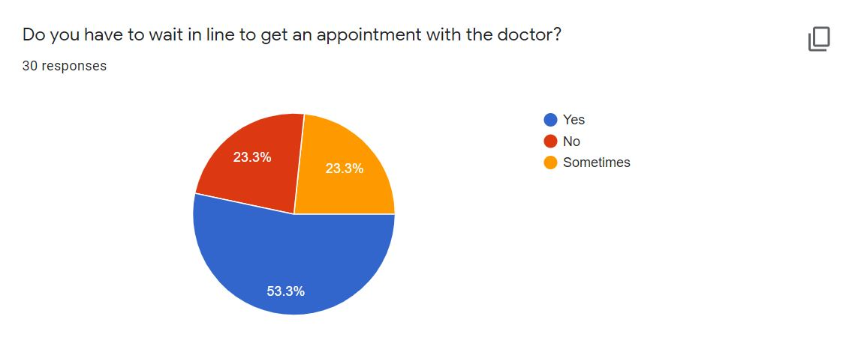

Figure 1: Survey of problem

According to a survey done, it was found that over 50% had to wait in long lines to get an appointment with the doctor whereas around 23% sometimes had to wait in lines.

## 

## 1.3 Project as a Solution

This Dental Appointment System is important for the country as technology grows fast in the world. The goal of developing this project is to provide better solutions to the problems faced by patients. This website will allow customers to schedule an appointment for their dental check-up from home or from the office. In the present situation, there is no such appointment system available in Nepal. Patients find it difficult to book an appointment for their dental check-up. Either they must wait a very long line in crowd or must call some known doctors to schedule an appointment. Patients can also view their reports in their profile, so they will never lose their dental record and it will be much easier to access it in future if the patients face any problems.

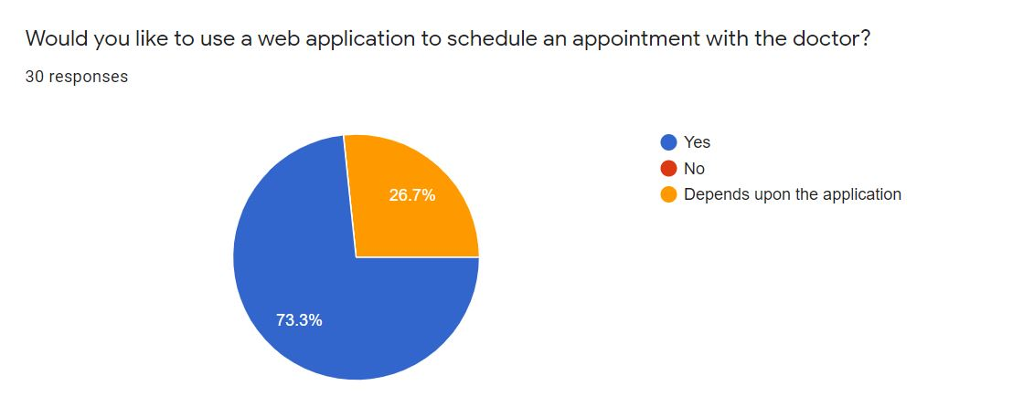

Figure 2: Survey of solution 1

According to the pie chart, it shows that over 70% of them would like to use a web based application to schedule an appointment with the doctor whereas the rest would like to use it depending upon the application.

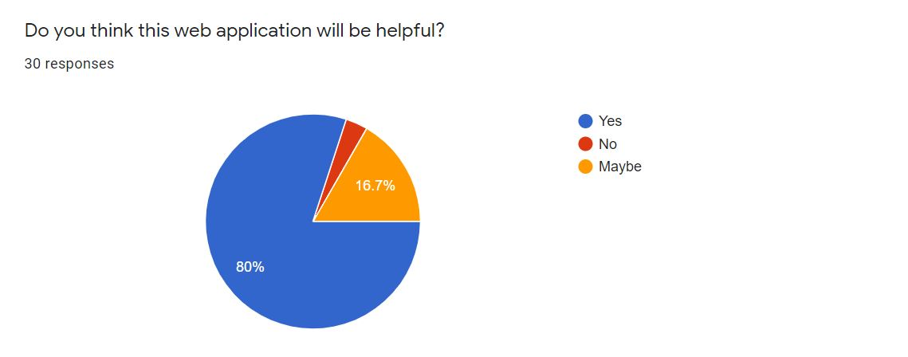

Figure 3: Survey of solution 2

According to the above pie chart of the survey, it was found that 80% of the people thought this web application will be useful whereas 16.7% thought it might be helpful.

At the end of this project, a prototype will be created that will provide a solution to the problem found. This system would be a web-based system where an overall online registration process and appointments will be carried out. Finally, the proposed system would save time for the patients.

## 1.4 Aims and Objectives

The primary aim of this project is to create a user-friendly web application that allows users to schedule a dental check-up appointment and save time rather than going to the clinic and waiting in line.

The following objectives are pursued in order to achieve this aim:

* To learn about the Python and its Django Framework along with it features.
* To use a relational database to comprehend and implement a database management system in the real world.
* To create a web application that allows to people book an appointment for their dental check-up.
* To work on the project using incremental methodology.
* Make the UI as user-friendly and interactive as possible.

## 1.5 Structure of the report

### 1.5.1 Background

* About end user
* Understanding the solution
* Similar Projects
* Comparisons

### 1.5.2 Development

* Considered Methodologies
* Selected Methodolgy
* Phases of methodology
* Survey Results
  + Pre-Survey Results
  + Post-Survey Results
* Requirement Analysis
* Design
* Implementation

### 1.5.3 Testing and Analysis

* Test Plan
  + Unit Testing, Test plan
  + System Testing, Test Plan
* Unit Testing
* System Testing
* Critical Analysis

### 1.5.4 Conclusion

* Legal, Social and Ethical Issues
  + Legal Issues
  + Social Issues
  + Ethical Issues
* Advantages
* Limitations
* Future Work

# 2. Background

## 2.1 About the end users

### 2.1.1 Discussion with client

Phulchowki Dental Care is a dental clinic located at Thaiba, Lalitpur. The founder and Managing Director of the clinic, Dr. Prashamsa Khadka has agreed to be the client for this project as she, including other staff, found this project very useful, feasible and effective.

According to Dr. Prashamsa Khadka, Founder and Managing Director of Phulchowki Dental Care, the following issues were identified during the discussion and meeting:

**Problem:**

According to her, there wasn't any system to book an appointment. People either had to call or wait in line. The lines were very long and sometimes very crowded as well. Especially in time of covid, it was very hard to even maintain social distance which increased the risk of transmission. She also stated that the records were written manually in a paper which made it very hard to access the records. Patients used to lose their reports frequently which made them difficult to have access to their previous history. So she had been looking for such system to implement.

**Solution:**

This system will allow users to book the appointment. Users can view the list of available doctors and select their desired doctors for their desired services. The system allows them to book, cancel and check the booking status. The report can also be uploaded which makes it easier for both patient and doctors.

**Client's Requirements:**

* Users should have their profile.
* Users should be able to book their appointment easily through the system.
* The system should also have features to cancel the appointment as well as check the appointment booking status.
* List of available doctors along with their description.
* Admin should be able to cancel user's appointment if the need arises.
* User should be able to view their report online as well.
* The Admin will manage the doctor's list and well as the user's list.
* The Admin will upload the doctor's approved report to the system for the user's to see.

### 2.1.2 End Users

The end users for the application will be multiple people who wants to book a dental appointment. The targeted users are the general public looking for an easier way to schedule a dental appointment with the doctor.

## 2.2 Understanding the solution

**2.2.1 Technology**

**Django Python Framework:**

For my project, I have decided to use the Django Python Framework. The reason I chose this framework is because it has better CDN connectivity and content management. It also has a faster processing. Django uses the MTV architecture due to which the transmission over the internet is easier and faster.

**HTML, CSS, JavaScript and Bootstrap**

For the frontend of the web application, I have decided to use HTML, CSS, JavaScript and Bootstrap, which is the framework of CSS.

**SQLite3**

For the database, I have decided to use SQLite to store the database. Django uses SQLite database by default so it is easier to use this database than others which is why I chose this.

**Visual Studio Code IDE:**

The IDEs that I will be using to develop the application is Visual Studio Code. Microsoft's Visual Studio Code (often known as VS Code) is a free open source text editor. Windows, Linux, and macOS are all supported by VS Code. Although the editor is minimal, it contains several strong capabilities that have helped VS Code become one of the most popular development environment tools in recent years.

**Hardware Requirements**

For the project to run, it doesn't need any high-end hardware device. Just a normal working device with a proper internet connection will work fine.

## 2.3 Similar Projects

**2.3.1 Dent-inn**

Dent-inn is a dental clinic located at Durbar-marg of Kathmandu, Nepal. The application is a web based application. In this application, you can fill out an online appointment form. The form requires name, phone, email, date, time, preferred doctor and message. However, you cannot select a particular service from the appointment from itself. There is also a section where you can view the in house doctors. In this application, you do not need register as a user. Anyone can just visit the website and book an appointment. There is no section for uploading report meaning you can only book an appointment for your dental check-up and nothing more.

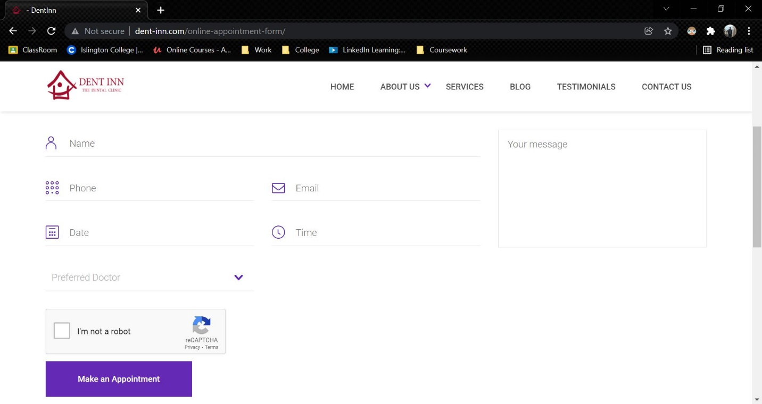

Figure 7: Dent-inn

Link to the website: <http://www.dent-inn.com/>

**2.3.2 DentaLife**

DentaLife is also a dental clinic located at Jamal, Kathmandu. Although the website is similar to Dent-inn, the appointment section of this web is quite different. It used google forms in order to collect the appointment details. This web uses no backend.

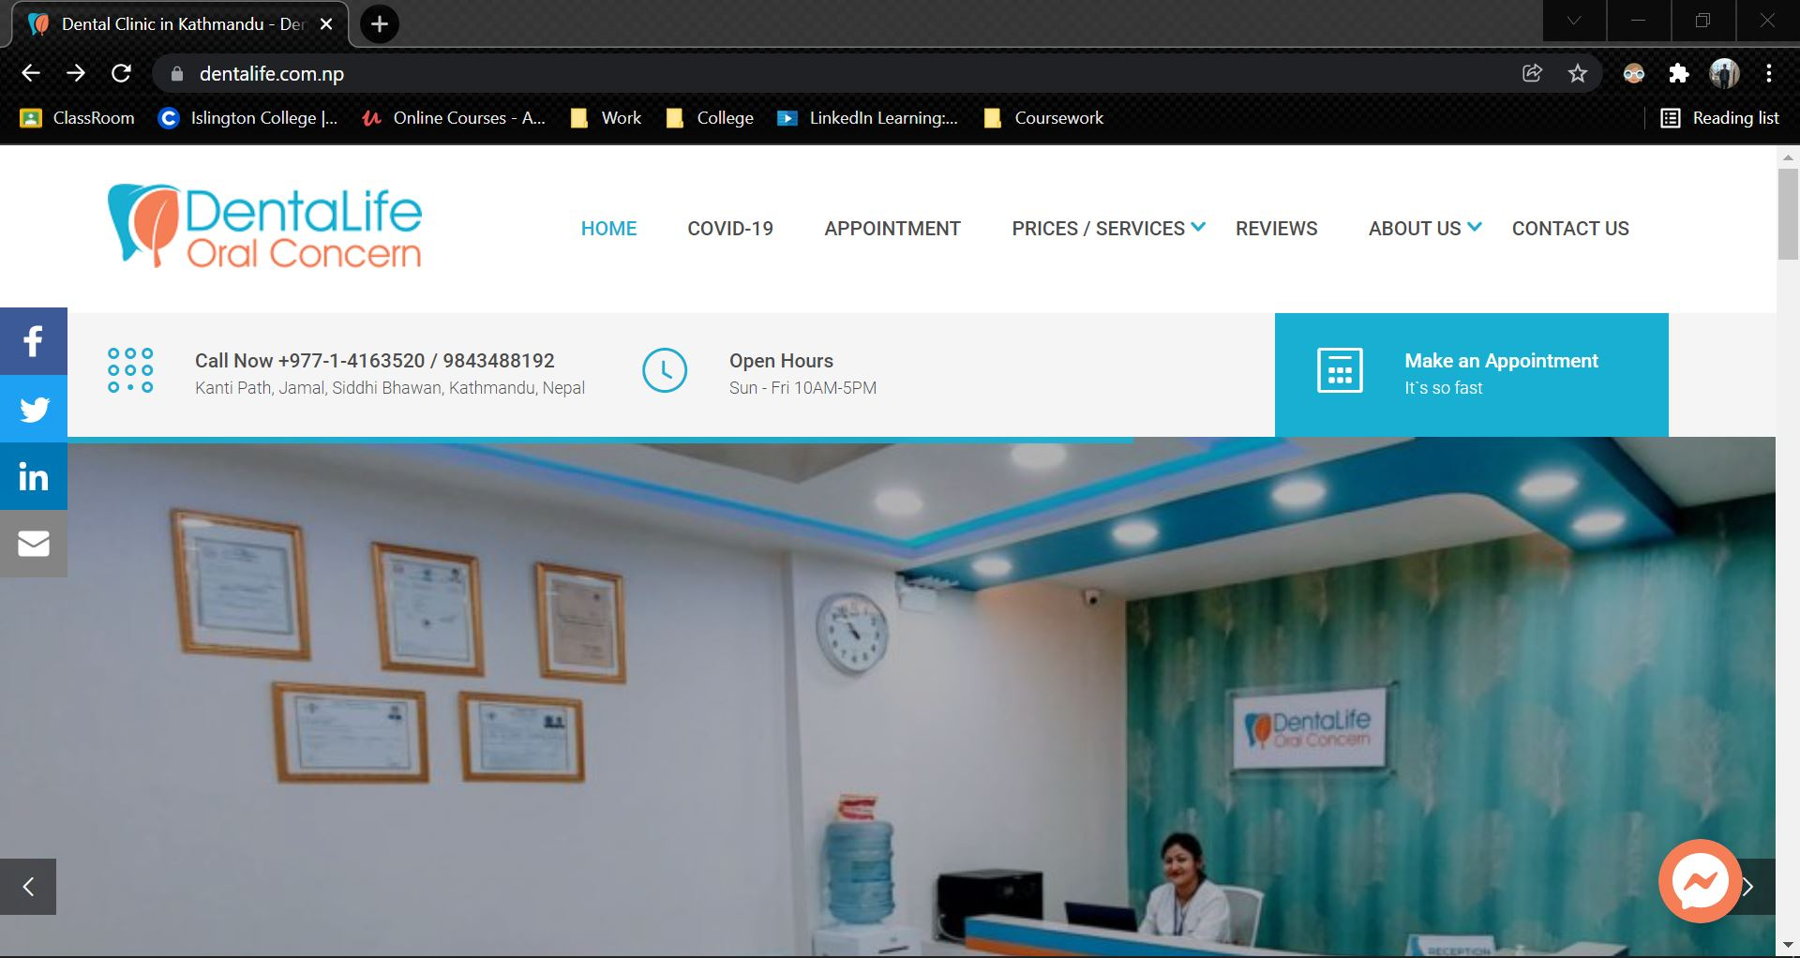

Figure 8: DentaLife

Link to the website: <https://dentalife.com.np/>

**2.3.3 Kumari Dental Care**

Kumari Dental Care is a dental clinic located at Jhamsikhel, Lalitpur. It is also a web based application where any user can book an appointment. In this web application, the first name, last name, email, needs and message. In this clinic, only one doctor is present. There is no login and register feature here as well. There is no report option here as well, meaning user will only use this website once for their appointment.

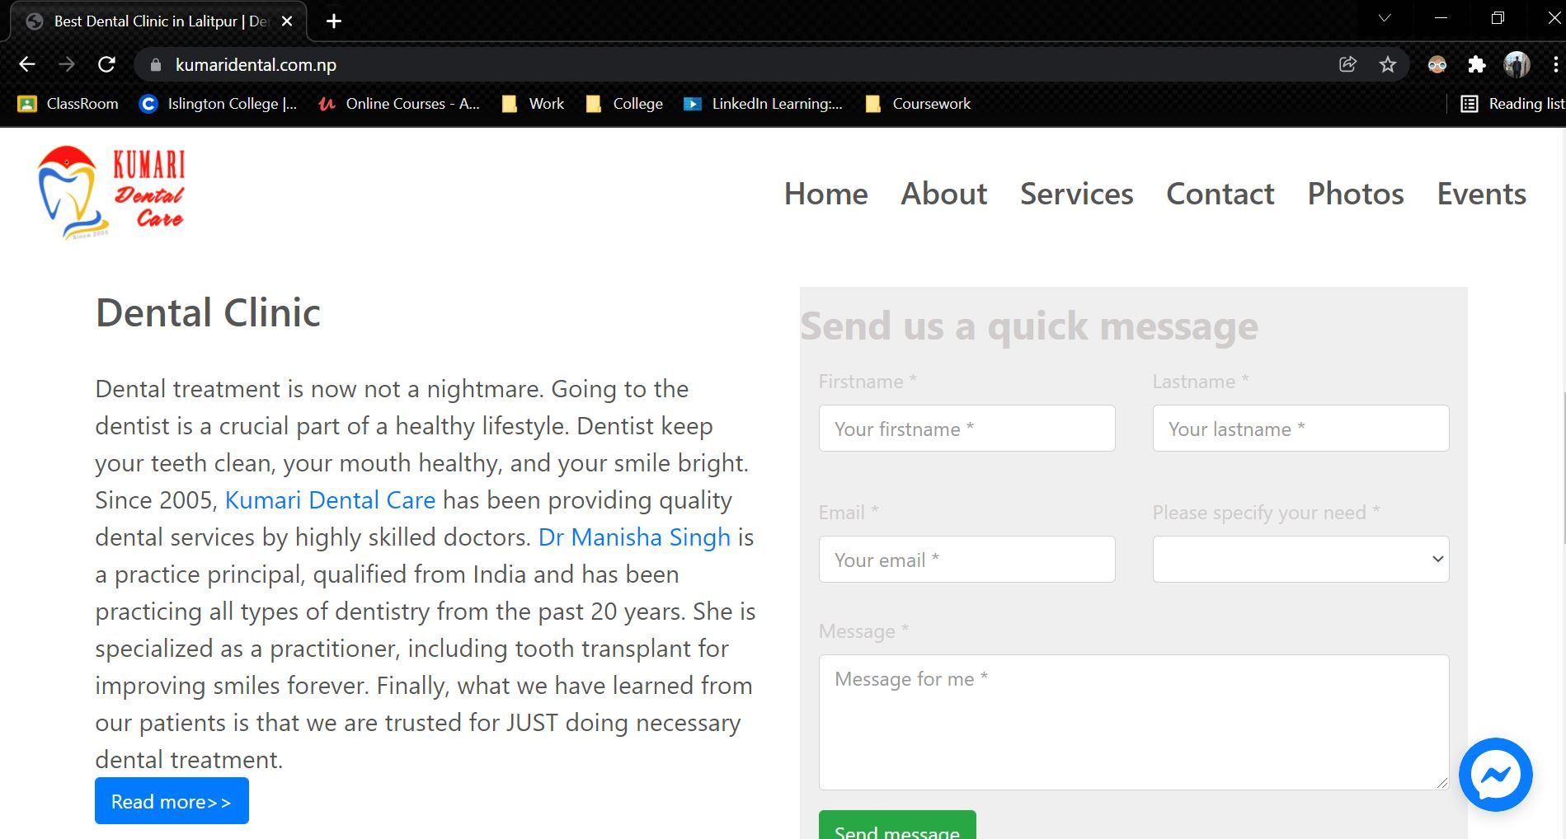

Figure 9: Kumari Dental Care

Link to the website: <https://kumaridental.com.np/index.html>

## 2.4 Comparisons

The table below shows the comparison of different web based applications for the online appointment booking system.

|  |  |  |  |  |  |
| --- | --- | --- | --- | --- | --- |
| S.No | **Features** | Dent-inn | DentaLife | Kumari Dental | My System |
| 1. | Online Appointment Booking Module | ✓ | ✓ | ✓ | ✓ |
| 2. | Doctor Selection | ✓ | ✓ | 🗶 | ✓ |
| 3. | Service Selection | 🗶 | 🗶 | ✓ | ✓ |
| 4. | View Report | 🗶 | 🗶 | 🗶 | ✓ |
| 5. | View Doctors | ✓ | 🗶 | ✓ | ✓ |
| 6. | Login | 🗶 | 🗶 | 🗶 | ✓ |
| 7. | Register | 🗶 | 🗶 | 🗶 | ✓ |
| 8. | Day and Time Selection | ✓ | ✓ | ✓ | ✓ |
| 9. | Extra Note | ✓ | ✓ | ✓ | ✓ |

Table 1: Analysis of Similar Project

# 3. Development

## 3.1 Considered Methodologies

**3.1.1 RUP Methodology**

The Rational Unified Process (RUP) is an approach for developing agile software. The project life cycle is divided into four phases by RUP. All six main development disciplines are practiced at each phase: business modelling, requirements, analysis and design, implementation, testing, and deployment. RUP provides a systematic way to build this type of system, focusing on the production of an executable architecture in the early stages of the project, that is, before committing resources on a large scale. (TestBytes, 2019)

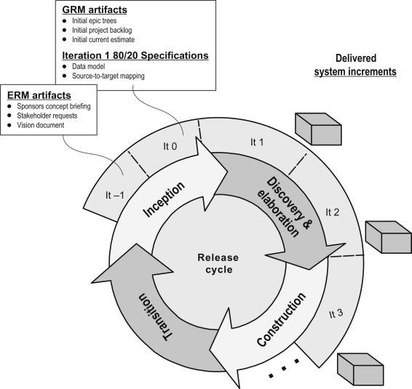

Figure 4: RUP Methodology (TestBytes, 2019)

**3.1.2 Prototype Methodology**

Prototype Model is a software development model in which prototype is built, tested, and reworked until an acceptable prototype is achieved. (Martin, 2021) It also serves as a foundation for the creation of the final system or software. It's best used in situations where the project's requirements aren't fully understood. It is an iterative, trial-and-error process that occurs between the developer and the client.

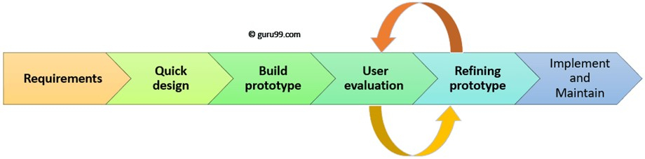

Figure 5: Prototype Methodology (Martin, 2021)

**3.1.3 Incremental Methodology**

In Incremental Methodology, first a simple working system is constructed and supplied to the customer, with only a few basic features. Over many successive iterations successive versions are implemented and delivered to the customer until the desired system is realised. (Mall, 2014) The following diagram shows the incremental development model:

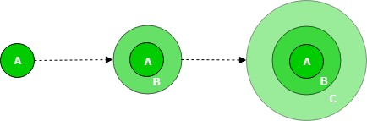

Figure 6: Incremental Methodology (GeeksForGeeks, 2019)

## 3.2 Selected Methodology

**Incremental Methodology**

I chose the Incremental Model methodology for my project. The incremental model is a software development technique in which the model is defined, implemented, and tested one step at a time until the product is complete. It consists of both development and maintenance. When a product meets all of its specifications, it is said to be done. This model combines the elements of the waterfall model with the iterative philosophy of prototyping. (Ghahrai, 2016) I picked this methodology over the iterative model because the iterative model requires us to receive input from the project manager after each feature. Furthermore, the incremental model differs from the iterative model in that the iterative model involves the addition of new features, whereas the incremental model involves the refinement of existing features. This approach is commonly utilized in the development of online applications. Also, I utilized incremental since the requirements and features are extremely clear and can be implemented and delivered in each phase.

The product is broken down into multiple parts, each of which is designed and constructed independently (termed as builds). When all of the components have been completed, they are delivered to the client. This allows for partial product usage while avoiding a lengthy development process. It also necessitates a significant upfront financial investment, with the long wait time eliminated. This model of development also helps ease the traumatic effect of introducing completely new system all at once.

(Ghahrai, 2016)

## 3.3 Phases of Methodology

There are 4 phases involves in the Incremental model and they are enumerated below:

**3.3.1 Requirement Analysis:**

The first stage in the incremental model is to analyse the product's problem situation and identify the specifications. The functional requirements of the system are understood by the requirement analysis team. This procedure is essential for designing apps utilizing the incremental model. All of the system's criteria are obtained during this procedure through study of publications, books, and web sites, as well as surveys and interviews with end users.

The requirements for my system were acquired through a survey and analysed based on how the end user would want to utilize the program and what features they desired.

**3.3.2 Design and Development:**

Following the collection of all specifications, the major functions and features to be employed in the software are determined. Risks are identified during this phase, as are the instruments that will be used. During this phase, wireframes, use case diagrams, collaboration diagrams, sequence diagrams, and class diagrams are also created. The functionality of the system and the development technique have been successfully designed.

After analysing the requirements, the general design of the project began with the creation of the system's wireframes. Following the creation of the wireframe, the class diagram and use cases for the overall system were established. Following the creation of the class diagram, the ERD for the system's database was created, and the system's code/development was initiated.

**3.3.3 Testing:**

After developing the system's functionality, it is tested in this phase to ensure that the developed system is fully functional and error-free. This phase assesses the consistency of all existing functionalities as well as the addition of new features. A variety of testing methods are utilized to test the activity of each task.

Following the end of the system's development, different forms of testing were performed, including unit testing, system testing, Blackbox testing, and Whitebox testing.

**3.3.4 Implementation:**

When the testing phase is finished, the project goes on to the implementation phase. It includes both the final coding developed during the development phase and the testing of the functionality during the testing phase. After this phase is completed, the number of working products is improved and updated all the way to the final system product. This phase reviews and discusses the entire system, as well as the features and modifications that will be required in future iterations.

After testing is completed, the system's final coding is accomplished, and the focus shifts to enhancing the system, fixing errors, and adding new features.

## 3.4 Survey

### 3.4.1 Pre-Survey Results

1. 43.3% of them have their dental check-up in over a year, 26.7% of them in a year, 26.7% in every 6 months and 3.3% in every 3 months.
2. 53.3% have to wait in line to get an appointment, 23.3% sometime have to wait in line and 23.3% of them doesn't have to wait in line.
3. 86.7% have never used an online appointment booking system whereas 13.3% have.
4. 73.3% said they would like to use a web based application to schedule an appointment with the doctor whereas the remaining 26.7% said it would depend on the application.
5. 80% thinks this application will be helpful, 16.7% thinks the application might be helpful whereas 3.3% thought it will not be helpful.
6. 76.7% thinks having an online report will be useful whereas 23.3% thinks it might be useful.

Link to the survey: <https://forms.gle/x1DkhUFqgoDTmZ886>

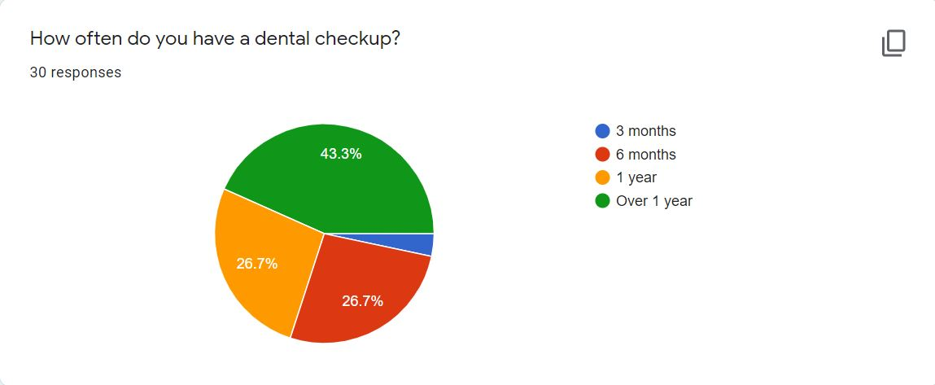

Figure 30: Survey Question 1



Figure 31: Survey Question 2

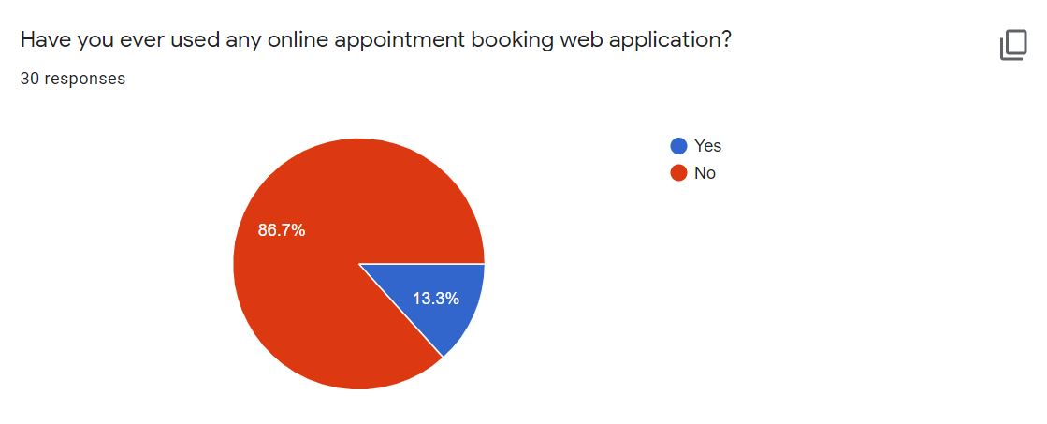

Figure 32: Survey Question 3



Figure 33: Survey Question 4



Figure 34: Survey Question 5

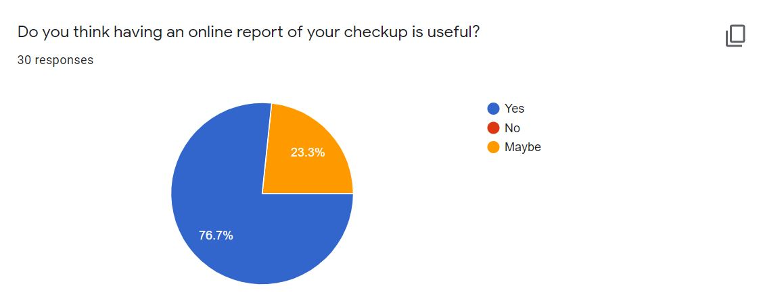

Figure 35: Survey Question 6

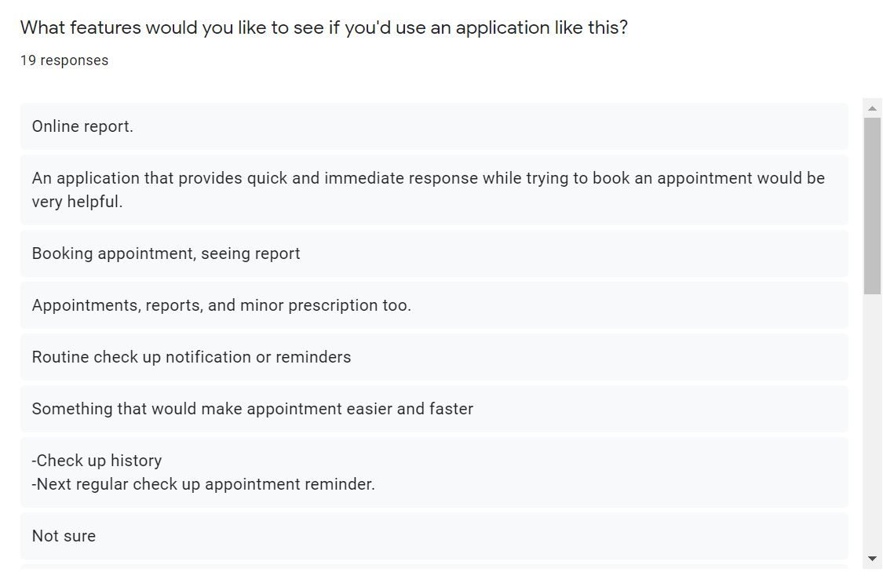

Figure 36: Survey Question 7

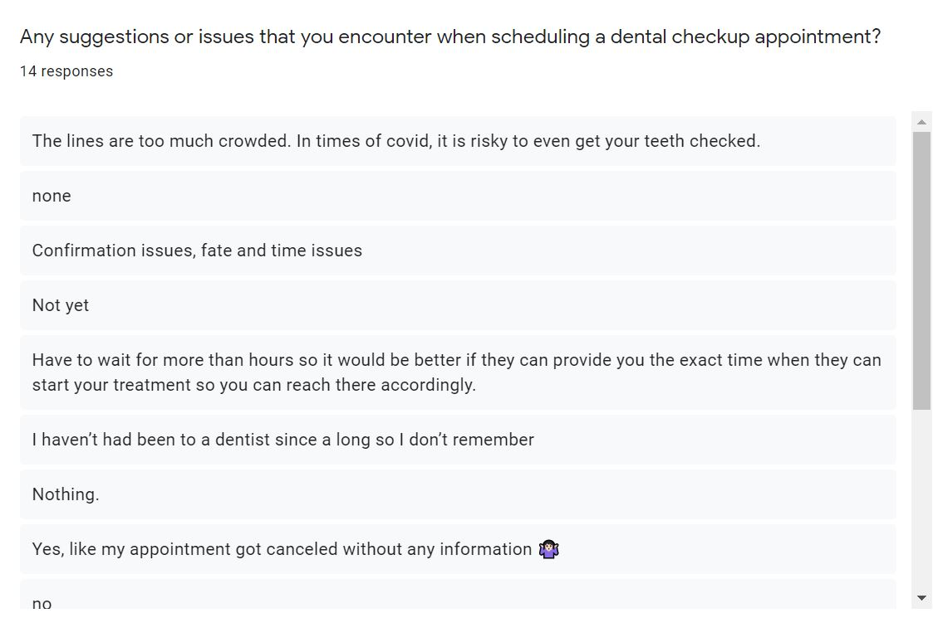

Figure 37: Survey Question 8

### 3.4.2 Post-Survey Results

## 3.5 Requirement Analysis

## 3.6 Design

## 3.7 Implementation

# 4. Testing and analysis

## 4.1 Test Plan

### 4.1.1 Unit Testing, Test Plan

### 4.1.2 System Testing, Test Plan

## 4.2 Unit Testing

## 4.3 System Testing

## 4.4 Critical Analysis

# 5. Conclusion

## 5.1 Legal, Social and Ethical Issues

### 5.1.1 Legal Issues

### 5.1.2 Social Issues

### 5.1.3 Ethical Issues

## 5.2 Advantages

## 5.3 Limitations

## 5.4 Future Work

# 6. Reference

Biscobing, J., 2021. *TechTarget.* [Online]   
Available at: https://searchdatamanagement.techtarget.com/definition/entity-relationship-diagram-ERD  
[Accessed 12 12 2021].

GeeksForGeeks, 2019. *GeeksForGeeks.* [Online]   
Available at: https://www.geeksforgeeks.org/software-engineering-incremental-process-model/  
[Accessed 10 12 2021].

Ghahrai, A., 2016. *DevQA.* [Online]   
Available at: https://devqa.io/software-development-methodologies/  
[Accessed 11 12 2021].

Martin, M., 2021. *Guru99.* [Online]   
Available at: https://www.guru99.com/software-engineering-prototyping-model.html  
[Accessed 10 12 2021].

TestBytes, 2019. *TestBytes.* [Online]   
Available at: https://www.testbytes.net/blog/rational-unified-process/  
[Accessed 10 12 2021].

VisualParadigm, 2021. *VisualParadigm.* [Online]   
Available at: https://www.visual-paradigm.com/guide/uml-unified-modeling-language/what-is-use-case-diagram/  
[Accessed 12 12 2021].

# 7. Appendix

## 7.1 Appendix A: Pre-Survey

### 7.1.1 Pre-Survey Form

### 7.1.2 Sample of filled pre-survey forms

### 7.1.3 Pre-Survey Result

## 7.2 Appendix B: Post-Survey

### 7.2.1 Post-Survey Form

### 7.2.2 Sample of Filled Post-Survey Forms

### 7.2.3 Post-Survey Result

## 7.3 Appendix C: Sample Codes

### 7.3.1 Sample code of the UI

### 7.3.2 Sample code for the Automation Script

## 7.4 Appendix D: Designs

### 7.4.1 Gantt Chart

### 7.4.2 Work Breakdown Structure

### 7.4.3 Algorithms and Flowcharts

### 7.4.4 Hardware Architecture

### 7.4.5 Data Flow Diagram

### 7.4.6 Use Case

### 7.4.7 Wireframes

## 7.5 Appendix E: Screenshots of the System

## 7.6 Appendix F: User Feedback

### 7.6.1 User Feedback Form

### 7.6.2 Sample of Filed User Feedback Forms

## 7.7 Appendix G: Future Work

### 7.7.1 Readings for future work